Where to insert
-for difficult anatomy or patients, bougie guided chest tubes are helpful
-You both hands on your kelly clamps to prevent going to deep, lock your elbows to your hips, and your weight to punch through the fascia
-sweep with your finger 360 and touch lung if possible to break up any adhesions and confirm your in the correct space
- while inserting the chest tube, aim apically and rotate the chest tube 360-720 to make sure the chest tube isnt kinked or caught on any structures
-more studies are showing 20fr chest tubes are adequate for trauma and are less painful for patients. Empyemas are indications for larger bore chest tubes.
(https://emcrit.org/wp-content/uploads/2021/12/The_small__14_Fr__percutaneous_catheter__P_CAT_.6.pdf)

-always better to go higher than lower to avoid diaphragm injury, especially in abdominal crush injuries
- Going 1-2 rib spaces above incision site can help guide tube apically
- NEVER cut breast tissue, displace the breast
-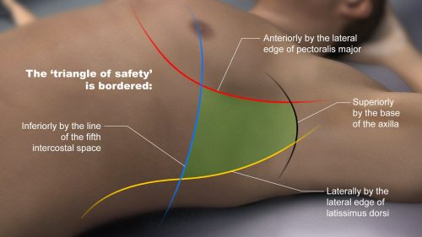
adultemergencymedicine.blogspot.com/

